Katlo Tutwane

Cse24-097@thuto.bac.ac.bw

REQUIREMENT ELICITATION & Behavioural Modelling

ASSIGNMENT: BANKING SYSTEM- PART A

1.INTRODUCTION

The purpose of this document is to capture the requirements within the given budget, design the structural and behavioural UML models, and provide a foundation for implementation. This banking system allows customers to log in, deposit, withdraw, apply interest, view transaction and importantly open accounts.

2.REQUIREMENT ELICITATION

2.1 Functional requirements

The system shall:

1. Allow a customer to register with personal details
2. Allow a registered customer to log in and out.
3. Allow a customer to open multiple types of accounts the system offers (savings, cheque and investment).
4. Allow a customer to deposit money into any account.
5. Allow withdrawals from only Savings and Cheque account.
6. Allow interest to be applied to investment and Savings account.
7. Record all deposits, withdrawals and transfers as transaction.
8. Allow customers to view all the transaction history.
9. Ensure that each individual account is uniquely linked to a customer.
10. Allow the customer to view all their accounts.

2.2 Non-functional requirement

The system shall:

1. Provide secure authentication to prevent unauthorised access.
2. Provide a user-friendly JavaFX interface
3. Support handling of multiple accounts and transactions(scalability).
4. Ensure fast processing of transaction under normal load.
5. Provide reliable error handling for failed transactions.

3.Structural UML Modelling

Class diagram

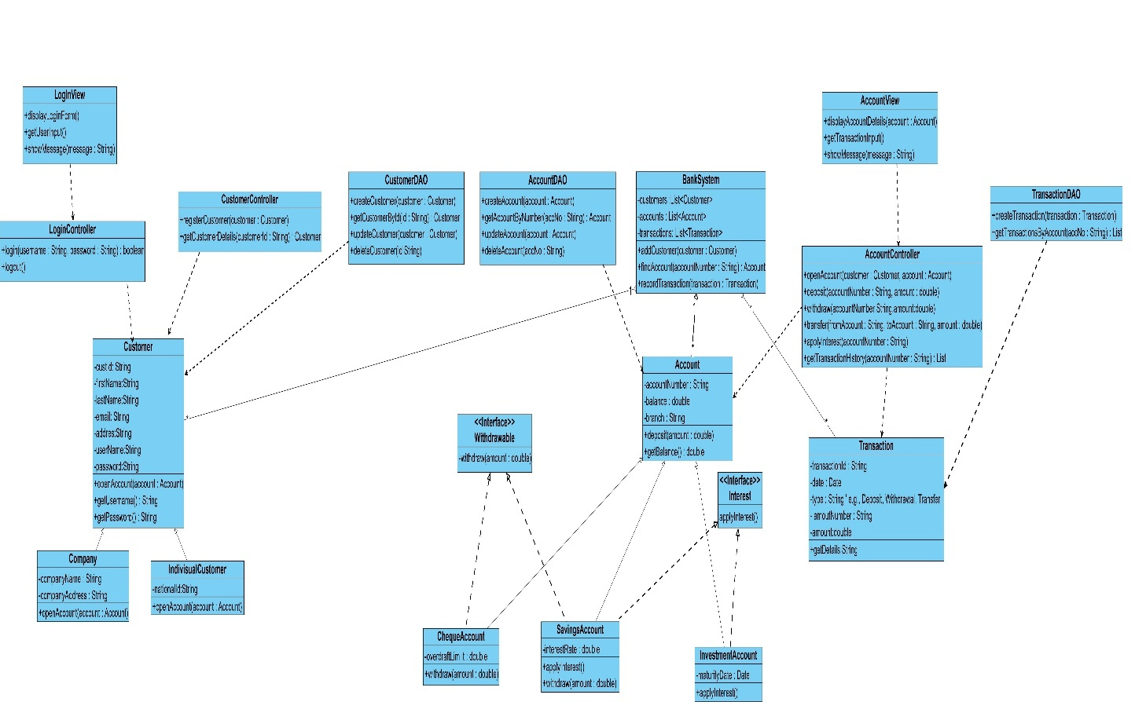

Please Zoom for a better view!!

Use case diagram

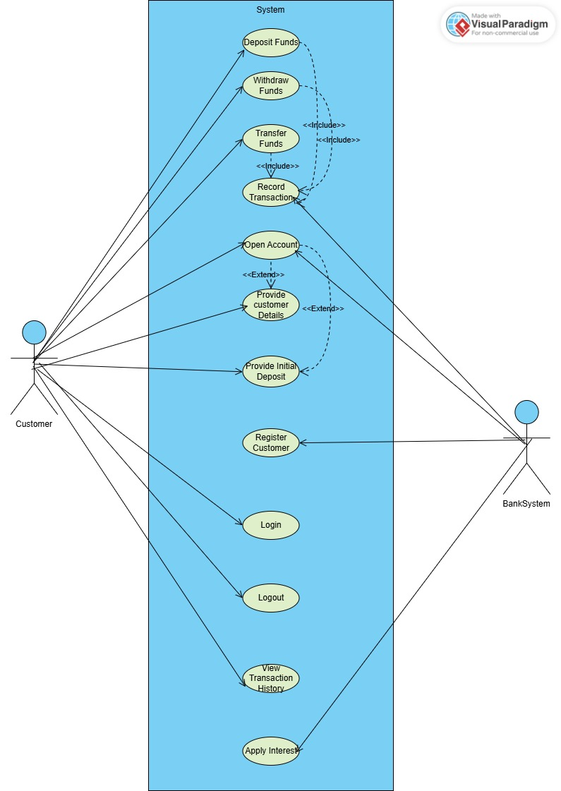

5.Behavioural Modelling

Sequence Diagram: Login

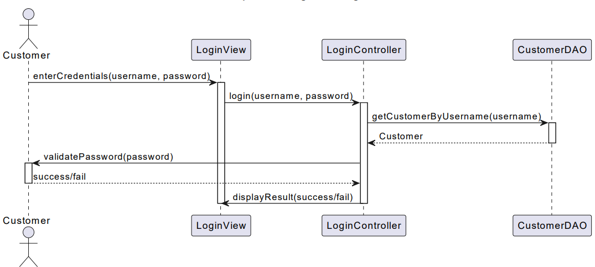

Sequence Diagram: Deposit

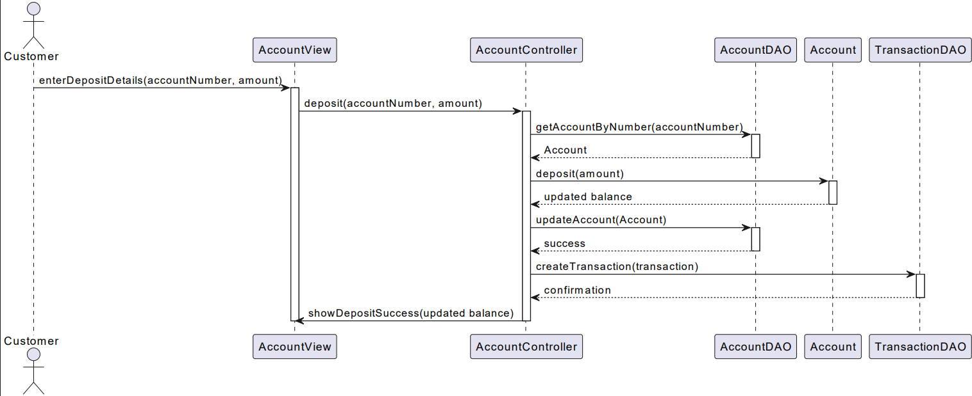

State diagram: Transaction Lifecycle

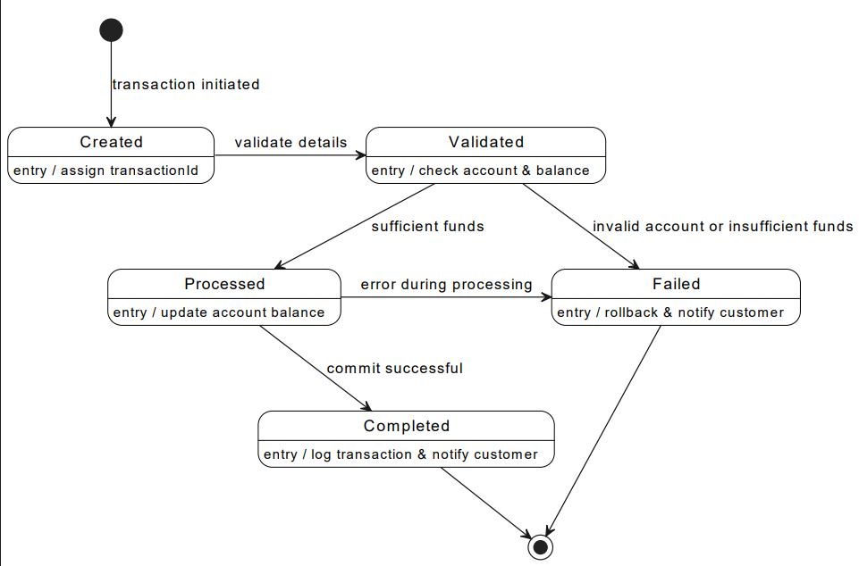

3.Interview Appendix

Date: 17/09/25

Interviewer: Katlo Tutwane

Interviewee: Mr Themba Moeng

Customer Management

1.**Question:** Do we need to support customer deletion after closing a profile, or should we disable it?

**Answer:** We should not delete the customer. instead, disable or make the profile inactive.

2.**Question:** Should the system support joint accounts (two customers sharing the same account)?

**Answer:** No, one customer should have their own accounts

Transactions

3.**Question:** Should there be transaction limits per day (maximum withdrawals, deposit)?

**Answer:** No limits, but every transaction should be recorded with type, amount, date, time, and related account.

4. **Question:** Should the system allow transfers between different customers, or only between a customer’s own accounts?

**Answer:** Transfers should be between the customer’s own accounts.

5.**Question:** Should failed transactions be recorded?

**Answer:** No, only successful transactions should be recorded.

6. **Question:** Do we need to support scheduled or automatic transactions (e.g salary deductions)?

Security, Authentication, and Access

7. **Question:** Should login require two-factor authentication (OTP via SMS/email), or just username and password?  
**Answer:** For simplicity, only username and password are required.

1. **Question:** Should there be an admin role to monitor customer accounts and transactions?  
   **Answer:** Yes, the bank side acts as the admin.
2. **Question:** Should the admin be able to freeze accounts?  
   **Answer:** No, freezing accounts is not needed.